# A ROBUST EDGE DETECTOR IN PRESENCE OF IMPULSE NOISE

|  |  |  |
| --- | --- | --- |
| T. Teja Sai Nadh Reddy  *Department of Information Technology*  *RVR&JC COLLEGE OF*  *ENGINEERING*  Guntur , India iamteja18@gmail.com | N. Tahgore Bala Channakya  *Department of Information Technology*  *RVR&JC COLLEGE OF*  *ENGINEERING*  Guntur , India channakya777@gmail.com | Dr. A. Srikrishna  Professor & HOD IT  *RVR&JC COLLEGE OF*  *ENGINEERING*  Guntur , India atlurisrikrishna@gmail.com |

***Abstract* : Edge detection is a challenging task with many applications in image processing. Edge detection in images can be accomplished using various methods and well-known operators. The effectiveness of these techniques is frequently influenced by the extent of image detail preserved and the application at hand. Edge detection amplifies the noise, which has a major impact on their structural features. Impulse noise, often known as salt-and-pepper noise, is one such type of noise that affects the quality of images. Smoothing filters are frequently used to eliminate this kind of noise from images in order to reduce the noise's variation and maintain the image quality. The study presents a novel technique for detecting edges in images that utilizes denoising methods to retain image details while preventing blurring and preserving sharp edges along boundaries, even when high impulse noise is present. The effectiveness of the proposed approach is evaluated by measuring its performance using Mean Squared Error (MSE),**

**Structural Similarity Index (SSIM), and Peak Signal-to-Noise Ratio (PSNR), and is compared to the commonly used CANNY Edge detector.**

***KeyWords* :Impulse Noise, Denoising, Median Filter, Mean Filter, Edge Detection, Non-Maximum Suppression**

Ⅰ. INTRODUCTION

In the modern era, digital images are a common medium for transmitting visual information. However, during the transmission process, these images are often subjected to unwanted disturbances, known as noise, which degrades the quality of the received image. In order to utilize the received image for any

applications, it is necessary to process it by applying either linear or nonlinear filters [1] to restore it to its original content. In the domain of image processing, there is a contemporary trend towards enhancing the efficacy of image handling, with a focus on improving clarity and performance to a significant degree. Digital images have a significant impact in various domains, including daily life applications such as satellite television, magnetic resonance imaging, and computer tomography, as well as in research and technology fields such as geographical information systems and astronomy. The advances of electronic technologies have led to the widespread use of digital images in our everyday lives. However, these images are vulnerable to corruption by various forms of noise, which can greatly diminish the quality of the image. During the acquisition and transmission of digital images, various types of noise can corrupt the image. To improve the image quality, different techniques for image enhancement or restoration are employed. The effectiveness of each method is contingent upon the quality of the input images. The Canny edge detection method [1] is widely recognized as one of the most valuable techniques available. This process consists of several complex stages that involve the use of Gaussian filtering to smooth the image, intensity gradient analysis, non-maximum suppression for edge thinning, thresholding, and edge tracking to ensure that edge connectivity and continuity are maintained. HED [2] utilizes convolutional neural networks for image training and prediction, employing multi-scale and multi-level feature learning techniques to achieve optimal results. While edge detection methods and their respective operators are capable of extracting edge information and delivering good performance with clean images, their effectiveness is significantly reduced in the presence of high-intensity impulse noise. Although such degradation can be remedied, it requires additional and carefully planned filtering steps. The Neuro-fuzzy operator [3] is intended for edge detection in the presence of impulse noise, but its effectiveness is restricted to low-intensity noise levels.

In [4], a rapid algorithm for detecting edges in noisy images was proposed, but its primary emphasis was not on preserving image details across various noise intensities. The comprehensive survey on switching median filters [17] compares denoising filters, such as the standard median filter [7], center weighted median filter (CWMF) [18], weighted median filter [19], adaptive switching median filter (ASMF) [20], and modified decision-based unsymmetric trimmed median filter (MDBUTMF) [21], providing a comparative assessment. To enhance the median filter's performance for high-intensity impulse noise, several studies [15, 16] have proposed methods, and the results indicate that MDBUTMF [21] outperforms them. Other switching-based filters, introduced in [22-25], are also available. The ANDWP filter, introduced in [31], is specifically designed to remove high-intensity random valued impulse noise (RVIN). Commonly used filters include the standard median filter [7], total variation (TV) filter [8, 9], anisotropic diffusion filter [10, 11], bilateral filter [12], guided filter [13], and non-local mean filter [14]. Among these, empirical evaluations have shown that the median filter performs best in the presence of impulse noise. In the first phase, contaminated pixels are detected by aligning the differences between the test pixel and its neighbours in the four main directions within a 5 x 5 window. In the second phase, only the noisy pixels are filtered based on the minimum variance of the four directional pixels. In literature Wilcoxon Test [9], [13] to detect edge pixels from a noisy image, find out the median of the neighbourhood pixels of centred pixels. Based on that statistical value decision will be made whether the pixel is edge pixel or not. Previous studies [32]-[33], [34]-[36] have proposed various approaches to detect edges in noisy images. These approaches typically involve performing regularization by selecting appropriate filters to reduce the noise present in the image. However, this can result in blurred or distorted edges, and in some cases, edge pixels may even disappear. To address this issue, operators with larger scope are used to average out localized noisy pixels. After reducing the noise, suitable edge detectors such as those proposed in [1] and [37] are applied to identify the edges in the restored image. The edge detection methods apply linear filters or nonlinear filters in order to detect edges. The derivative edge detection methods [32] covers to obtain the edges from original images directly which cannot be obtained if applied directly on noisy images and methods [38]-[40] listed may obtain edge images directly from a noisy image without regularization.

In this study, a technique for detecting edges in images with high levels of impulse noise is introduced. The method involves a denoising process that reduces the impact of impulse noise, even at high intensities. The proposed technique combines a switching adaptive median filter with a fixed weighted mean filter (SAMFWMF) to effectively preserve edge detail for optimal edge detection. The performance of the proposed method is evaluated using various metrics, such as high correlation, structural similarity index, and peak signal-to-noise ratio. To mitigate edge discontinuities and noisy pixels in the presence of high-intensity noise levels, the non-maximum suppression method is employed to track edges.

Ⅱ. METHODOLOGY

The proposed approach involves using SAM and FWM filters to remove high impulse noise from an image, while also utilizing the Sobel operator to detect edges. To evaluate the effectiveness of the method, a regular image is first used, and then noise is added to it to simulate an image with impulse noise. The method is then used to denoise this noisy image, and the resulting denoised image is compared to the original image. The complete process is given in block diagram as shown in fig.1

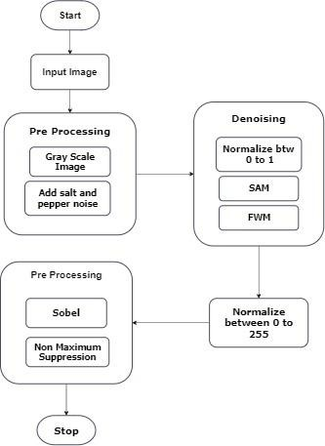

Fig 1: Block diagram of proposed method *Denoising Methods*

The proposed denoising method, referred to as SAMFWM, incorporates two main components: switching adaptive median (SAM) filtering and fixed weighted mean (FWM) filtering, along with an additional shrinkage window. The procedural steps of this method are designed to effectively reduce noise and enhance image quality. *A. Switching Adaptive Median (SAM)*.In Switching Adaptive Median the pixels are normalized between 0 to 1. Assume the noise model as given in (1), assuming normalization:

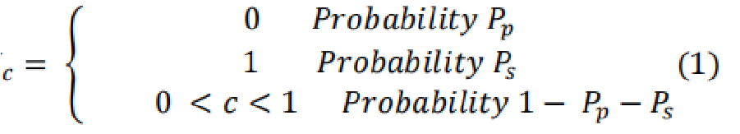

The normalized representation of corrupted pixels are 0 for the pepper with probability

Pp and 1 for the salt noise with probability Ps. The pixel values that are not corrupted lies in between 0 and 1. In switching adaptive median filter an initial window size of 3x3 is used. The window is convoluted over the whole image and the central pixel of the window is replaced with the median value of that window. The size of the window increases if the variance of that window is greater than the two times the median of that window. The presence of an edge can be inferred by observing a high difference between pixel values. This can be indicated by a variance that is significantly higher than the median value (σ > 2Median). To confirm the presence of an edge, larger window sizes are used to validate the variance. If an edge is detected, the median value is assumed to be able to detect it. However, if no edge is detected, the median value is likely to be influenced by the texture within the window. The decision to increase the window size beyond the original 3x3 size is only made if the SAM filter did not effectively remove all the noise from the image. To further address any remaining noise in white and black regions, an adaptive additional window is employed. This approach prevents blurring of the final SAMFWM image that could result from increasing the window size in the SAM filter.

*Algorithm For SAM Filter :*

for Ii,j ∈ image do

Wmin = Minimum window size (3*3) Wmax = Maximum window size (5*5) n = zeros(size(I))

for Ix,y∈ W, Wmin ≤ W ≤ Wmax do

Smin = Sort(W)

M = Median(Smin)

1. = Length(Smin) V = Variance(Smin)

if L ≠ 0 and V > 2*M then

W = Wmax

Smax = Sort(W)

1. = Median(Smax) n(i,j) = M

I = n

Steps:

1. Initialize the window to 3*3.
2. Sort the current window of the image and calculate the value of median of that window
3. Also, Calculate the Length(L) and Variance(V) of the window.
4. If the Length(L) is not equal to zero and Variance(V) Less than 2*Median then

4.1. The central pixel value is replaced with the Median of that window.

**5**. Else if Length(L) is not equal to zero and Variance(V) greater than 2*Median then

5.1. Window size is increased to 5*5.

5.2. Repeat steps 2,3.

5.3. The central pixel value is replaced with the Median of that window.

**6**. The resulting image is the resulting Switching Adaptive Median (SAM) Image.

## B. Fixed Weighted Mean (FWM)

Given a mean filtered image with fixed parameters, a 2x2 window is used to convolve over the image. During this process, the pixel at position (i,j) is checked along with its adjacent pixels (i.e., I(i, j+1), I(i+1, j), I(i+1, j+1)) to determine if it has been corrupted (i.e., I(i,j) has a normalized value of either 0 or 1).

If a corrupted pixel is detected and its corruption is due to salt or pepper noise, the pixel is assigned a new value based on specific weights, as described in (2). Otherwise, the pixel remains unchanged.



The equation involves N, which is equal to

4. The set Snew(i, j) is defined as {I(i,j+1), I(i+1, j), I(i+1, j+1)}, where (i, j) represent the position of the corrupted pixels, and (x,y) represent the coordinates of the surrounding pixels. In this method, if the detected corrupted pixel is caused by salt or pepper noise (with probabilities ps or pp), the weights wx,y are chosen directly based on the probability of the neighboring pixels having a value of 1 or 0, as determined by one of the following conditions:

* Suppose a corrupted pixel has been detected in a window containing only 0's and 1's. In this scenario, the weight wx,y is assigned a value of 2 for the pixels located to the east and south of the corrupted pixel, while the weight for the southeast pixel (i.e., the pixel diagonally adjacent to the corrupted pixel) is set to 1.
* When all the neighbouring pixels have the same value, the weight assigned to each pixel wx,y is set to 1.

Steps:

1. Initialize a 2*2 window for convolution of the image
2. Calculate Mean and Weighted Mean according to the above conditions

**3**.Calculate sum of the window

4. If the number of 1’s is greater than number of 0’s then

* 1. Ix,y is replaced with mean of the window.

Else

4.2. Ix,y is replaced with weighted mean of the image.

5. If the sum is greater than or equal to 3 then the pixel value remains unchanged.

Fixed Weighted Mean filter (FWM) focuses only on the pixels that are remained corrupted after performing SAM. FWM highlights the edge pixels and sharpens the edge pixels.

## Algorithm For Fixed Weighted Mean (FWM)

for Ii,j ∈ image do

W2*2 = 2*2 Window Size

S = Current Window

mean = (Σ(x,y) in SIx,y)/3

Wmean = (Σ(x,y) in SIx,ywx,y)/3

sum = mean*3

if Ii,j = 1 or 0 then

if Ix,y = 1 then

Count1++

else count0++

if count1 > count0 then

Ii,j = mean

else

Ii,j = Wmean

if sum **≥ 3**

Ii,j = mean

else

Ii,j =Wmean

else

Ii,j =Ii,j

Where

* I(i, j) refers to the image
* Mean refers to current mean of the window
* Wmean refers to weighted mean of the window
* S refers to current window of the image

## Edge Detection Methods

## C. SobelOperator

The Switching Adaptive Median and Fixed Weighted Mean Filter is used to remove salt and pepper noise from impulsive noise images. After the denoising process, the Sobel operator is applied to the filtered image to detect edges. The Sobel operator computes the gradient in both horizontal (x) and vertical (y) directions.

The Sobel gradient operator computes the gradient value of a pixel by taking a weighted sum of the neighboring pixels within a 3-by-3 region. Specifically, different weights are assigned to the pixels in the horizontal (x) and vertical (y) directions.

|  |  |  |  |  |  |  |  |  |  |  |
| --- | --- | --- | --- | --- | --- | --- | --- | --- | --- | --- |
| |  |  |  | | --- | --- | --- | | -1 | 0 | 1 | | -2 | 0 | 2 | | -1 | 0 | 1 | |  |

X-direction Y-direction

Gr( f (i, j) ) = (f (i-1, j-1)) + 2( f (i-1, j) ) +

(f (i-1, j+1) - (f (i+1, j-1)) - 2( f (i+1, j)) -

(f (i+1, j+1))

Gc( f (i, j) )=(- f (i-1, j-1) - 2( f (i, j-1)) f (i+1, j-1)) + (f (i-1, j+1) + 2( f (i ,j+1) +

(f (i+1, j+1))

Where

* Gr represents gradient over the rows (i.e Y-Direction Kernel)
* Gc represents gradient over the column (i.e X-Direction Kernel)

Overall Gradient Magnitude is G=√ (Gr2+ Gc2)

## D. Non-Maximum Suppression

This technique is employed to thin out edges in grayscale images by comparing the strength of each edge to that of its neighbouring pixels, in accordance with the gradient direction.

In summary, the entire process can be described as follows:

* Calculate the vertical and horizontal gradient.
* The vertical and horizontal gradients are given by
* Calculate the angle of the gradient
* Angle = tan-1(G r/ Gc)

Gr(f (i, j) ) = (f (i-1, j-1)) + 2( f (i-1, j) ) +

(f (i-1, j+1) - (f (i+1, j-1)) - 2(f (i+1, j)) -

(f (i+1, j+1))

Gc(f (i, j) )=(- f (i-1, j-1) - 2( f (i, j-1)) f (i+1, j-1)) + (f (i-1, j+1) + 2( f (i ,j+1) +

(f (i+1, j+1))

Algorithm For Non-Maximum Suppression

for each pixel (i, j) in the image:

Calculate the gradient magnitude M and direction D if D is 0 degrees:

if (i,j) > (i, j+1) && (i, j-1):

mark (i, j) as an edge pixel

else if D is 45 degrees:

if(i,j) > (i-1, j+1) && (i+1, j-1):

mark (i, j) as an edge pixel

else if D is 90 degrees:

if(i,j) > (i-1, j) && (i+1, j):

mark (i, j) as an edge pixel

else if D is 135 degrees:

if(i,j) > (i-1, j+1) && (i+1, j-1):

mark (i, j) as an edge pixel

else:

mark pixel (i, j) as non-edge pixel

Non maximum Suppression Is used to thin out the edges on the image obtained after applying the Sobel operator.

Ⅲ. RESULTS AND DISCUSSIONS

Experiment Set

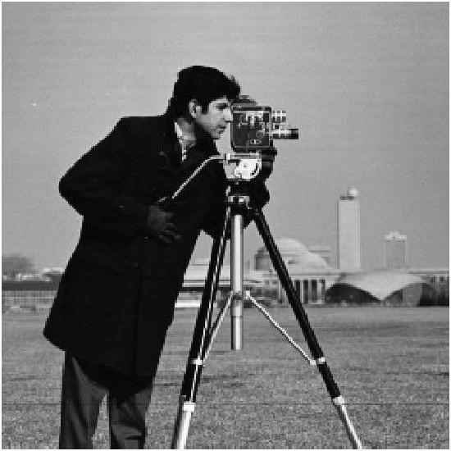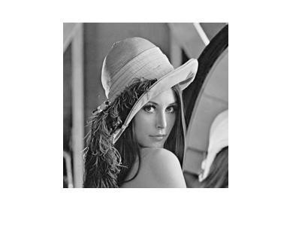

(a) (b)

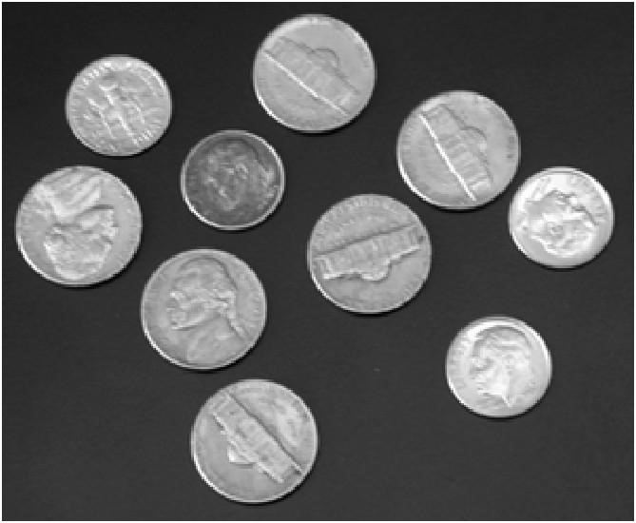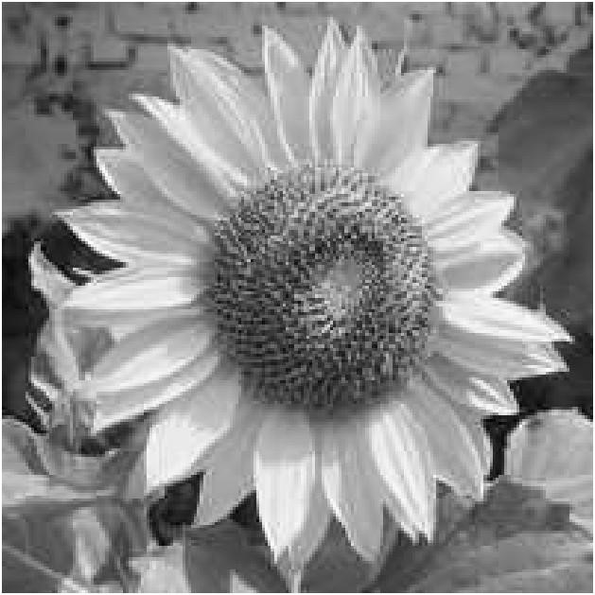

(c) (d)

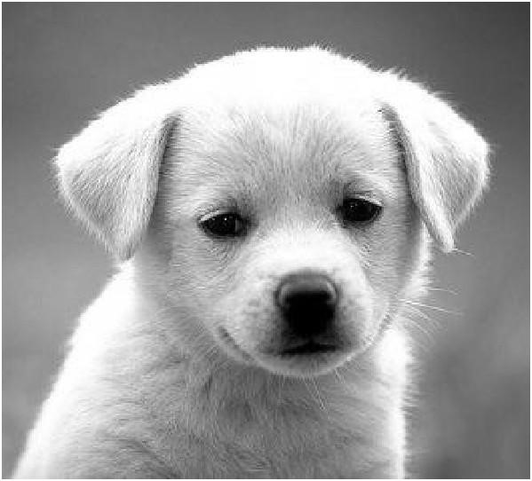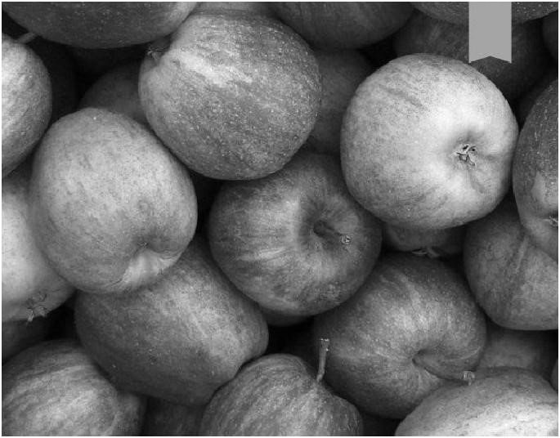

(e) (f)

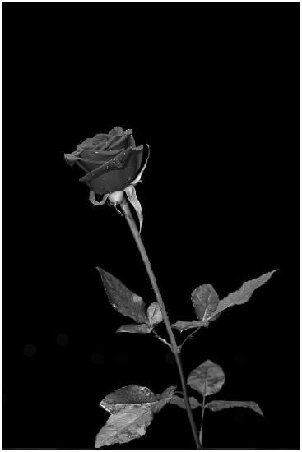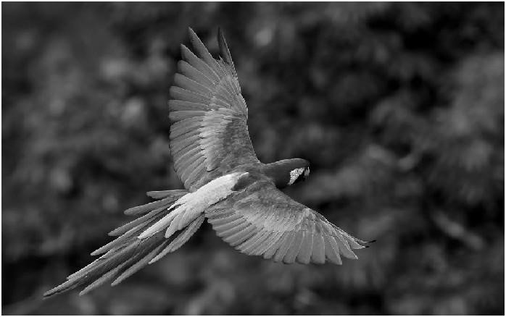

(g) (h)

The Experiment Set consists of 8 images which were used for denoising and edge detection

## Performance Metrics

Three performance metric measures are used to compare the proposed method and various techniques, They are

1.Mean Square Error (MSE)

2.Structural Similarity Index(SSIM)

3.Peak Signal-To-Noise Ratio(PSNR)

## 1.Mean Square Error (MSE)

The Mean Squared Error (MSE) value indicates the average pixel difference between the original image and the processed image. A higher MSE value indicates a greater difference between the two images.

Formula for calculating MSE is as follows:

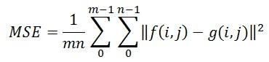

Where

**“f”** refers to the matrix data of the original image.

**“g”** refers to the matrix data of the degraded image under consideration.

**“m**” corresponds to the number of rows of pixels in the images.

**"i"** indicates the index of a specific row.

**"n"** is the number of columns of pixels in the image, **"j"** indicates the index of a particular column.

## 2.Structural Similarity Index (SSIM)

A metric for measuring the quality of an image by evaluating the visual impact of three distinct characteristics:

1.Luminance

2.contrast

3.structure

The output of the SSIM measurement is a numeric array that matches the dimensions of the input images. Each element of this array represents the SSIM measurement of the corresponding spatial location in the input image, across any channel or batch dimension.

The formula for calculating the SSIM[26] is as follows:

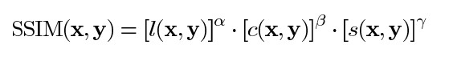

Where, **l** is Luminance comparison function **c** is Contrast comparison function and **s** is

Structure comparison function

*3. Peak Signal to Noise Ratio (PSNR)*

The peak signal-to-noise ratio (PSNR) is a metric that compares the maximum possible power of a signal to the power of distorting noise that degrades its representation, thus reflecting the quality of the signal. To account for the wide dynamic range found in many signals, the PSNR is typically measured using the logarithmic decibel scale.



Where,

*MAXf* is the maximum possible pixel value of the image

MSE is the mean square error.

Ⅳ. RESULTS

To determine whether the proposed method outperforms existing techniques, subjective and objective assessments are conducted on the images. Subjective assessment involves measuring image quality based on the subjective evaluations of human observers. This can be achieved through the use of an absolute rating scale or through side-by-side comparison of output images produced by different methods. Objective assessment can be conducted by employing various metrics such as PSNR, MSE, and SSIM, which are commonly used for analyzing image quality in an objective manner. Higher PSNR, higher SSIM indicates better image quality and lower MSE indicates batter image quality.

## A. Subjective Analysis

**Comparison of denoising Filters :**

The proposed SAMFWM Filter images are brighter and sharper and have less noise than the Median filter and Mean Filter. The median filtered and mean filtered images are slightly on the side of smoothing the image while the proposed method kept details and the overall look is better than the median and mean filtered images.

The Figure 5.3.1.1 Shows the denoised images obtained by applying general Median filter and proposed SAMFWM method directly on a Lena image corrupted with 10% impulse noise. The image obtained by the proposed method is better in handling noise keeping the details intact.

The figure 5.3.1.3 , 5.3.1.6 shows the denoised images obtained by applying general Median filter and proposed SAMFWM method directly on a coin and Dog image corrupted with 10% impulse noise. The image obtained by applying the proposed method is brighter, sharper and has high contrast ,maintaining a more optimal image. The same for over mean filter. All the figures of 5.3.1 shows the results of the denoised images on applying median filter and proposed SAMFWM method on 10% impulse noise.

The corrupted pixel undergoes through two processes SAM and FWM to correct the pixel thereby obtaining the optimal overall result. The proposed method can even do better than the standard mean and median filter even in noisy situations.

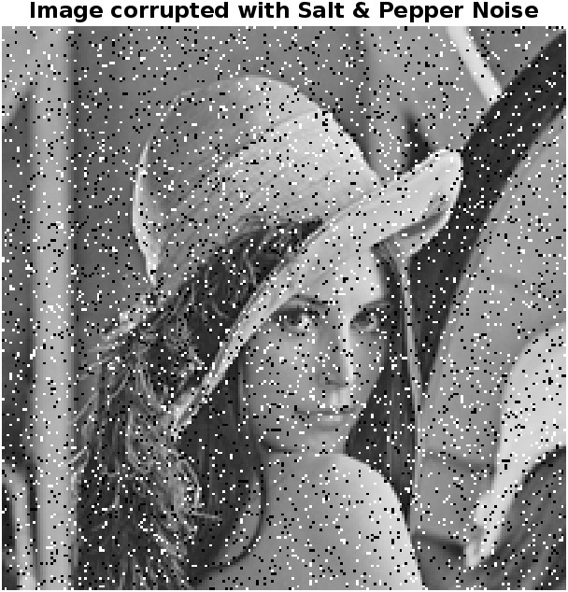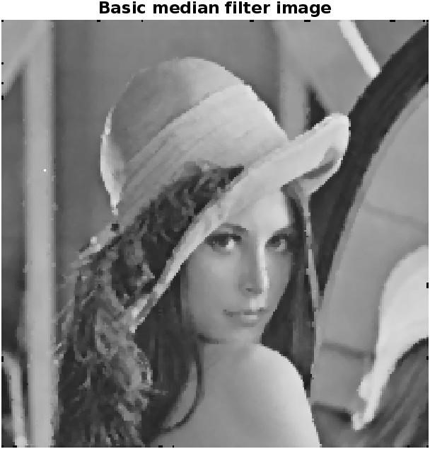

1. (b)

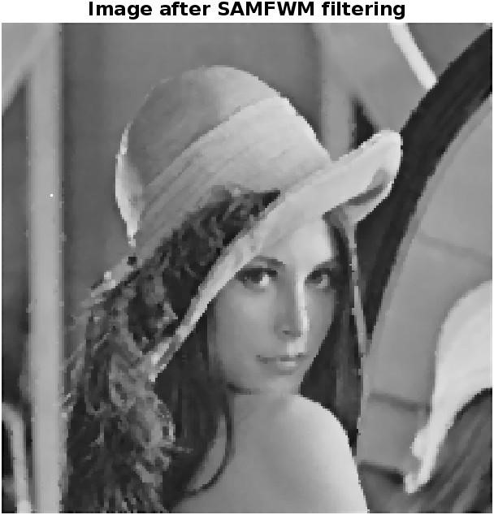

(c)

Fig 1 (a) Lena impulse noise image,

(b) Lena Median Filter

(c) Proposed SAMFWM method

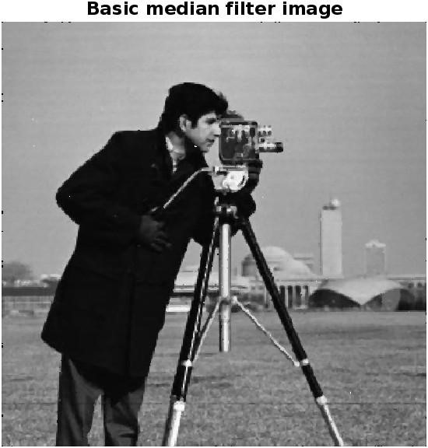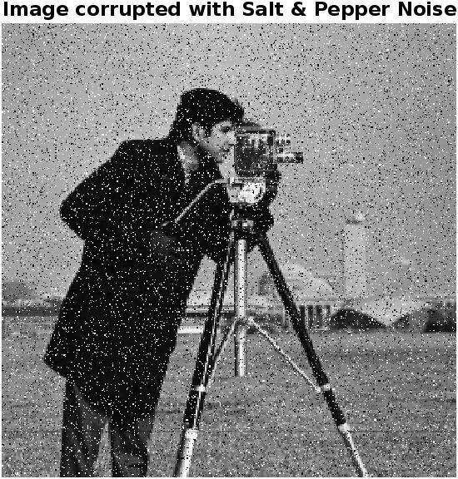

(d) (e)

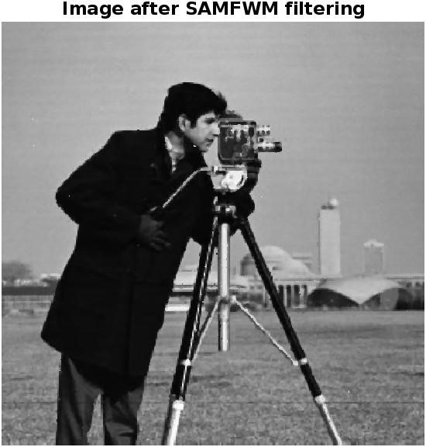

(f)

Fig 2 (d) Cameraman impulse noise image,

(e)Median Filter

(f) Proposed SAMFWM method

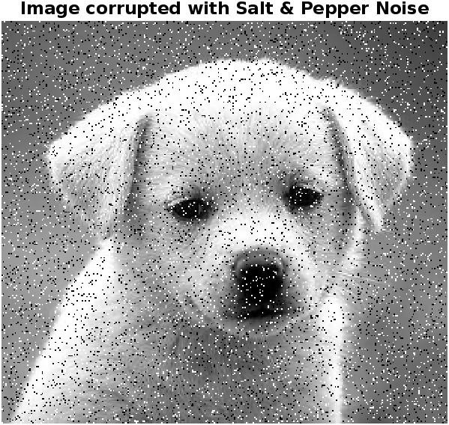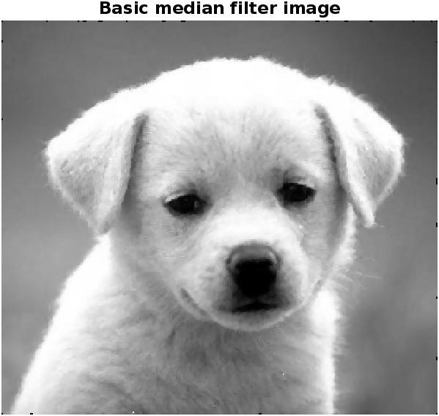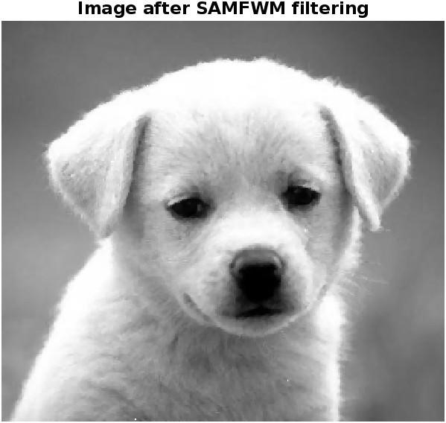

Fig 3 (g) Coins impulse noise image,

(h) Median Filter

(i) Proposed SAMFWM method

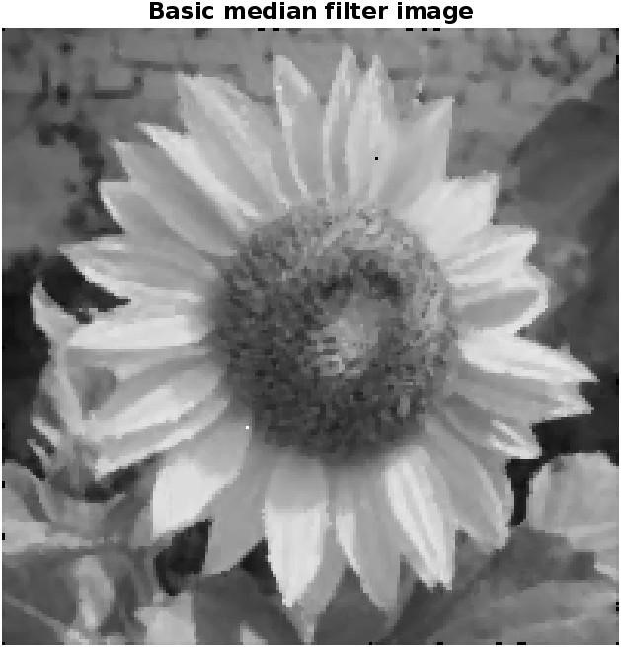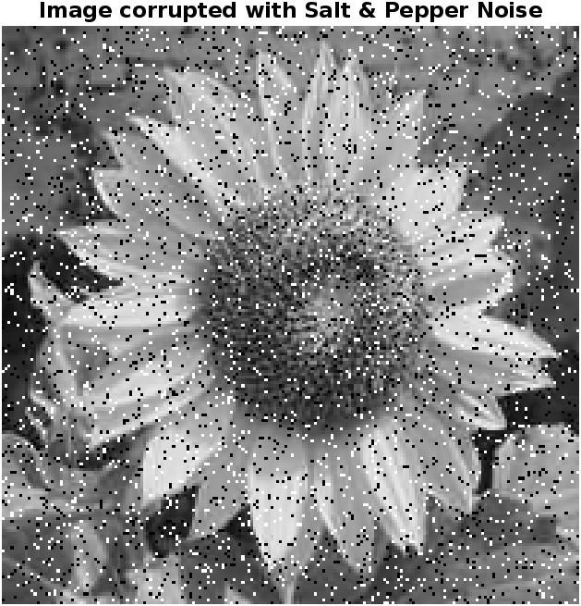

(j) (k)

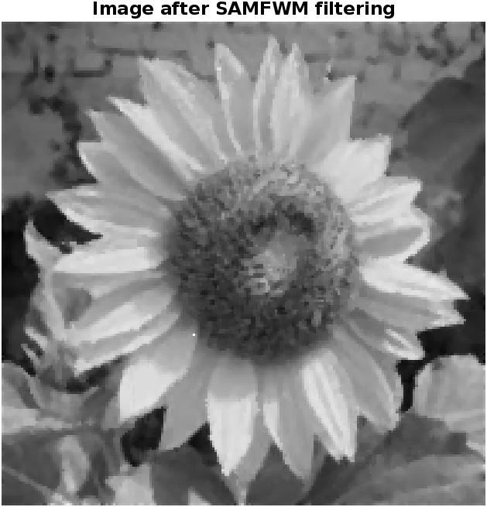

(l)

Fig 4 (j) Flowers impulse noise image,

(k) Median Filter

(l) Proposed SAMFWM method

**Comparison of Edge Detection:**

The Figure 5.3.1.9 Shows the edge images obtained by applying Proposed edge detection, sobel edge detection, canny edge detector directly on different images corrupted with 10% impulse noise. It is also observed that efficient edges are extracted by the Proposed method only in all the regions of an image and works well for images corrupted by impulse noise.

The dog image of the three methods can be observed in figure 5.3.1.9. Canny edge detector failed to produce all the edges and even the edge connectivity is not good. The edges obtained by sobel are very thick. The proposed method keeps in check of those two disadvantages and maintains good edge connectivity and thin edges over the image.

The same can be observed on the Lena, camera man image, flower, bird images .In all these different types of images proposed method maintains good edge connectivity and thinner edges.

**Comparison between Sobel vs Canny vs**

**Proposed algorithm**

**(a)**

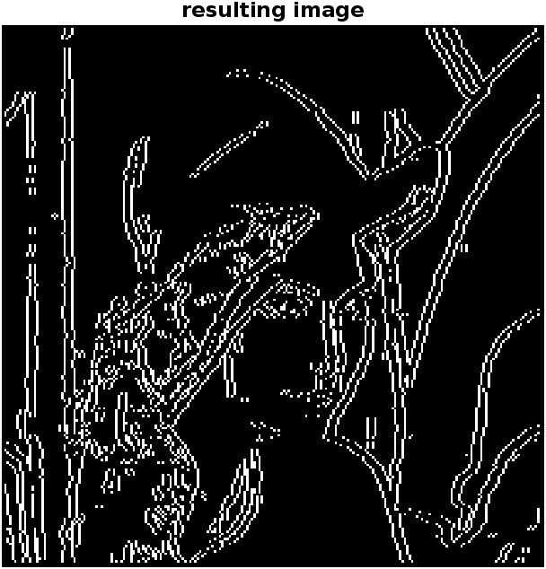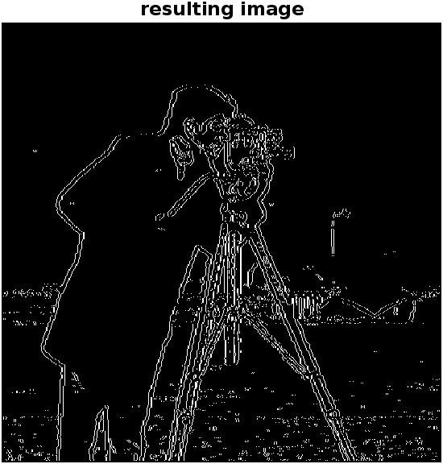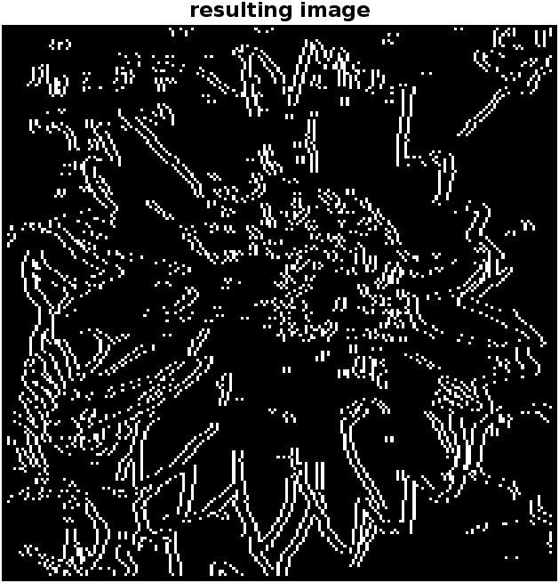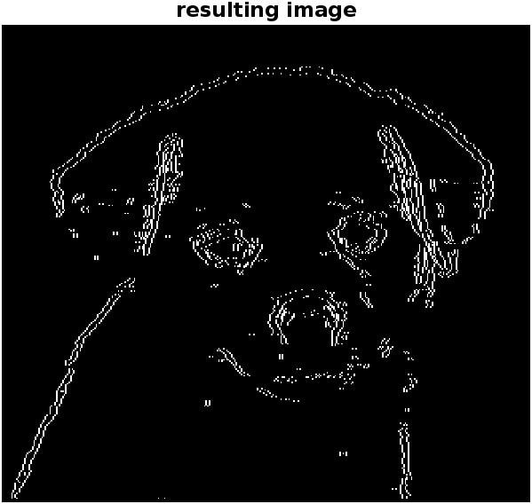

Edge Detection Using Proposed

Method

**(b)**

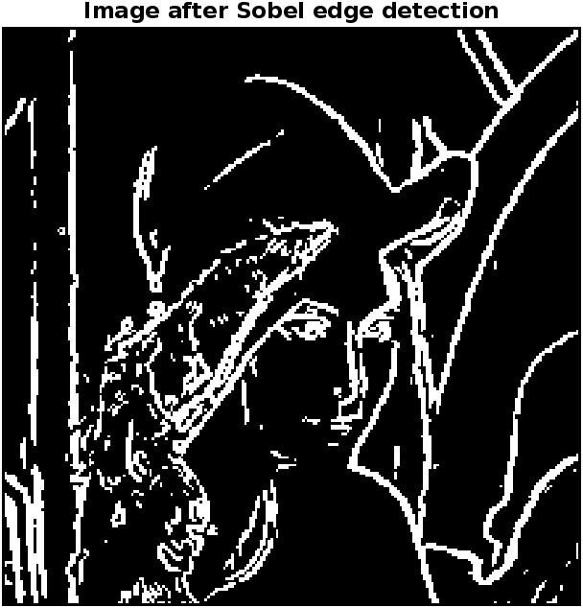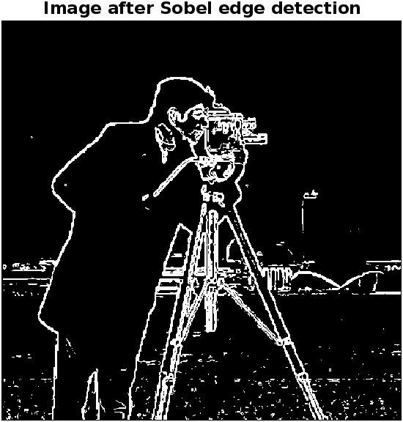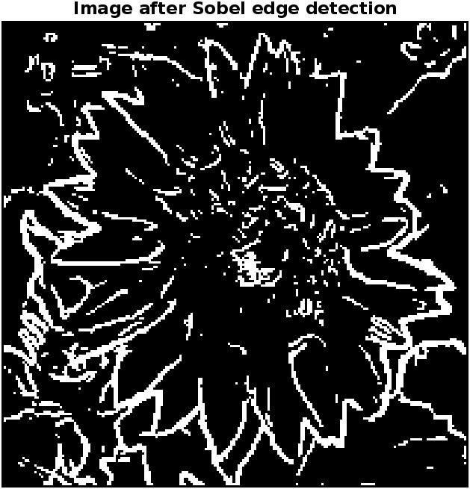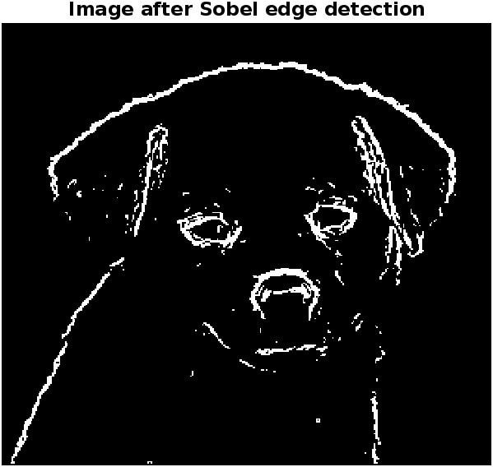

Edge Detection Using Sobel

Operator

**(c)**

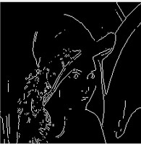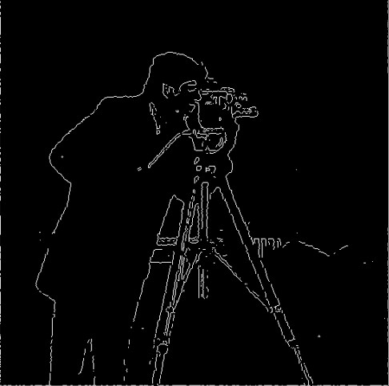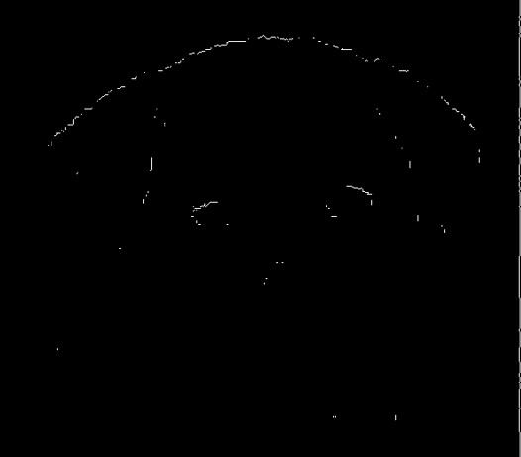

Edge Detection Using Canny

Method

Sobel obtained thick edges while canny lost the edges.The proposed method managed to thin edges while having the clear edges.

## **B. Objective Analysis**

The Objective assessment is to compare the denoising methods and edge detectors applied on these denoised images. The Results obtained by applying median filter, mean filter, SAMFWM on several are presented in the tables I, II, III.

The metrics used to compare the three denoising filters are peak signal to noise

Fig 9 (a) Proposed Edge Detection (b) ratio (PSNR), structural similarity index

Sobel Edge Detection (c) Canny Edge

(SSIM), mean square error (MSE).

Detection

The higher the value of PSNR and SSIM, lower the value of MSE higher is the image

The proposed method for edge detection quality.

exhibits superior performance compared to traditional methods such as Sobel and Canny edge detection.

|  |  |  |  |  |  |  |  |  |  |
| --- | --- | --- | --- | --- | --- | --- | --- | --- | --- |
|  | Lena | Camera man | Coins | Lena | Camera man | Coins | Lena | Camera man | Coins |
| PSNR | -22.6093 | -19.3298 | -24.8395 | -22.7016 | -19.4319 | -24.8415 | -22.2171 | -18.9183 | -24.7506 |
| MSE | 175.6018 | 85.6996 | 304.7562 | 177.5012 | 89.4581 | 305.4332 | 163.0297 | 77.9519 | 298.5771 |
| SSIM | 0.7742 | 0.7583 | 0.5930 | 0.7698 | 0.7509 | 0.5904 | 0.7803 | 0.7648 | 0.5749 |

Median Filter Mean Filter SAMFWM

Table I: PSNR, MSE, SSIM results of Lena, Camera Man, Coins for Median Filter, Mean

Filter, SAMFWM (proposed method)

Median Filter Mean Filter SAMFWM

|  |  |  |  |  |  |  |  |  |  |
| --- | --- | --- | --- | --- | --- | --- | --- | --- | --- |
|  | Flower | Apple | Dog | Flower | Apple | Dog | Flower | Apple | Dog |
| PSNR | -23.4927 | -28.0134 | -15.0488 | -23..5004 | -28.0111 | -15.0443 | -23.1065 | -27.9472 | -15.0384 |
| MSE | 223.4973 | 632.9079 | 31.9801 | 225.3428 | 630.1965 | 31.9876 | 204.4807 | 623.3279 | 31.9039 |
| SSIM | 0.7820 | 0.6855 | 0.9526 | 0.7698 | 0.6812 | 0.9501 | 0.7930 | 0.6882 | 0.9475 |

Table II: PSNR, MSE, SSIM results of Flower, Apple, Dog for Median Filter,

Mean Filter, SAMFWM (proposed method)

Median Filter Mean Filter SAMFWM

|  |  |  |  |  |  |  |  |  |  |
| --- | --- | --- | --- | --- | --- | --- | --- | --- | --- |
|  | Rose | Bird | Leaves | Rose | Bird | Leaves | Rose | Bird | Leaves |
| PSNR | -19.0107 | -13.3256 | -23.4514 | -18.6439 | -13.2994 | -23.4592 | -18.1439 | -13.2194 | -23.2984 |
| MSE | 79.6280 | 21.5062 | 221.3834 | 71.6783 | 21.1891 | 221.9834 | 65.2220 | 20.9865 | 213.7191 |
| SSIM | 0.8824 | 0.8908 | 0.6940 | 0.8891 | 0.8919 | 0.6929 | 0.8793 | 0.8936 | 0.6955 |

Table III: PSNR, MSE, SSIM results of Rose, Bird, Leaves for Median Filter, Mean Filter, SAMFWM (proposed method)

The tables I, II, III present the values of PSNR, MSE, SSIM of different images. Higher value of PSNR indicates better image with lower noise. The proposed method got better PSNR results than median and mean filters with the lower presence of noise and better image quality.

Lower the MSE value better is the image. In comparison of all the images MSE is lower for the proposed method in comparison with the median and mean filters which is an indication of better image quality.

Higher the SSIM the better the image is. SSIM gives the structural similarity index when comparing the denoised image to the original image which shows closeness to the original image. For every image SSIM is better for the proposed SAMFWM than the median and mean filter.

# Ⅴ. CONCLUSION

|  |
| --- |
| high-intensity impulse noise  **REFERENCES** |

A Robust switching adaptive median (SAM) filter has been proposed. It is assumed that the filtered images maintain a high degree of correlation with the original images, ensuring that edges accurately follow their true routes even in the presence of high-intensity impulse noise. To evaluate the effectiveness of the proposed method in preserving edges and maintaining image structure, standard metrics are calculated and used to compare the performance using

different filters. These metrics are also used to assess the quality the imageafterthesmoothingprocess has been applied. Experiments shows that PSNR, SSIM, MSE is high in the proposed algorithm compared to existing methods. The proposed method efficiently identifies the exact location of edge pixels in noisy images by examining a larger number of neighbors at varying scales. The results demonstrate that this approach outperforms existing methods in detecting edges, even in the presence of

[1] J. Canny, “A Computational Approach to Edge Detection,” IEEE Trans. Pattern Anal. Mach. Intell, vol.PAMI-8, no.6, Nov. 1986. [2] S. Xie, Z. Tu, “Holistically-nested edge detection,” In Proc. IEEE Int. Conf. Comput. Vision, pp. 1395–1403 (2015). [3] M. E. Yukse, “Edge detection in noisy images by neuro-fuzzy processing,” Elsevier, Int. J. Electron. Commun. vol.61 pp.82 – 89, 2007.

1. Y. Shi, Q. Zhao, F. Guo, Y. Zhu, “A Fast Edge Detection Model In Presence of Impulse Noise,” in Proc. Springer 8th Int. Conf. Image Graph., Tianjin, China, vol.9217, pp. 64-74, Aug. 2015
2. P. Jain, V. Tyagi, “A survey of

edge-preserving image denoising methods,” Springer, Inform. Syst. Front. , vol.18, no.1, pp. 159–170, Feb. 2016.

1. C. Pal, Amlan Chakrabarti, Ranjan Ghosh, “A Brief Survey of Recent

Edge-Preserving Smoothing Algorithms on Digital Images,” Elsevier, Procedia Comput. Sci., pp.1-40, Mar. 2015.

1. R. C. Gonzalez, R.E. Woods, “Digital image processing,” 3th ed., Upper Saddle River, NJ, Prentice-Hall, 2006.
2. L. I. Rudin, S. Osher, E. Fatemi,

“Nonlinear total variation based noise removal algorithms,” Elsevier, Physica D J., vol.60, no.1-4, pp.259–268, 1992.

1. A. Chambolle, “An Algorithm for Total Variation Minimization and Applications,” J. Math. imaging Vis., vol. 20, no.1, pp.89-97, Jan. 2004.
2. P. Perona, J. Malik, “Scale-Space and

Edge Detection Using Anisotropic

Diffusion,” IEEE Trans. Pattern Anal. Mach.

Intell., vol.12, no.7, .Jul. 1990.

1. G. Gerig, O. Kubler, R. Kikinis, F. A. Jolesz, “Nonlinear Anisotropic Filtering of MRI Data,” IEEE Trans. Med. Imag., vol.1, no.2, Jun. 1992.
2. C. Tomasi, R. Manduchi, “Bilateral Filtering for Gray and Color Images”, in Proc. IEEE, 6th Int. Conf. comput. Vis., Bombay, India, Jan. 1998.
3. K. He, J. Sun, X. Tang, “Guided Image Filtering,” IEEE Trans. Pattern Anal. Mach. Intell., vol.35, June. 2013.
4. A. Buades, Bartomeu Coll, Jean-Michel Morel, “A non-local algorithm for image denoising,” in Proc. IEEE Computer society Conf. Comput. Vis. Pattern Recog., vol.2, pp.60- 65, Jun. 2005.
5. R. Yang, L. Yin, M. Gabbouj, J. Astola, T. Neuvo, “Optimal weightedmmedian filtering under structural constraints” IEEE Trans. Signal Process., vol.43, no.3, pp. 591–604, 1995.
6. G. Qiu, An improved recursive median filtering scheme for image processing”, IEEE Trans. Image Process., vol.5, no.4, pp. 646–648, 1996.
7. S. Vishaga, S. L. Das, “A Survey on

Switching Median Filters for Impulse Noise Removal,” in Proc. IEEE Int. Conf. Circuit, Power Comput. Tech., Mar. 2015.

1. S. J. Ko and Y. H. Lee, “Center Weighted Median Filter,” IEEE Trans. Circuits Systs., vol. 3, no.9, pp 984-993, Sep. 1991.
2. Y. Dong, S. Xu, “A New Directional Weighted Median Filter for Removal of Random-Valued Impulse Noise,” IEEE Signal Process. Lett., vol.14, no. 3, Mar.

2007.

1. V. V. Khryaschev, A. L. Priorov, I. V. Apalkov, P. S. Zvonarev, “Impulse Denoising Using Adaptive Switching Median Filter,” in Proc. IEEE 2 th Int. Conf.

Image process., Sep. 2005.

1. S. Esakkirajan, T. Veerakumar, A. N. Subramanyam, C. H PremChand, “Removal of High Dendity Salt and Pepper noise

Through Modified Decision based Unsymmetrical Trimmed Median Filter,” IEEE Signal Process. Lett., vol.18, no.5, May 2011.

1. H. L. Eng, K. K. Ma, “Noise adaptive soft-switching median filter,” IEEE Trans. Image Process., vol.10, no.2, pp. 242–251, 2001.
2. R. Yang, L. Yin, M. Gabbouj, J. Astola, T. Neuvo, “A New impulse detector for switching median filters,” IEEE Signal Process. Lett., vol.9, no.11, , pp. 360–363, 2002.
3. P.-E. Ng, K.-K. Ma*,* “A Switching Median Filter With Boundary

Discriminative Noise Detection for Extremely Corrupted Images,” IEEE Trans.

Image Process., vol. 15, no. 6, pp.1506-1516, Jun. 2006.

1. I. F. Jafar, R. A. AlNa’mneh, K. A. Darabkh, “Efficient Improvements on the BDND Filtering Algorithm for the Removal of High-Density Impulse Noise,” IEEE Trans. Image Process., Vol. 22, No. 3, Mar. 2013.
2. Z. Wang, Alan Conrad Bovik, Hamid Rahim Sheikh, Eero P. Simoncelli, “Image Quality Assessment: From Error Visibility to Structural Similarity,” IEEE Trans. Image Process., vol. 13, no. 4, Apr. 2004. [27] A Descriptive Algorithm for Sobel Image Edge Detection, O. R. Vincent and O. Folorunso, Proceedings of Informing

Science & IT Education Conference

(InSITE), (2009).

1. Median filtering frameworks for reducing impulse noise from grayscale digital images: a literature survey, Teoh and Ibrahim, S.H. Teoh, H. Ibrahim, 2012 Int. J. Future Comp. Commun., 1 (4) (Dec. 2012), pp. 323-326
2. Nandhini and Nalini, 2014, M. Nandhini, T. Nalini, “Survey of image denoising algorithms” Int. J. Adv. Res. Comp. Sci., 5 (3) (March 2014), pp. 179-182 [30] S. Kaur and I. Singh, “Comparison between Edge Detection Techniques”, International Journal of Computer Applications, vol. 145, no.15, (2016), pp. 15-18.

[31] J. K. Mandal and Somnath

Mukhopadhyay “A Novel Technique for Removal of Random Valued Impulse Noise

Using All Neighbor Directional Weighted

Pixels (ANDWP)” Part of the Communications in Computer and Information Science book series

(CCIS,volume 203).

[32].Gonzalez, R.C., Woods, R.E (2008). Digital Image Processing. Prentice Hall, Englewood Cliffs, NJ . [33]. Pratt W.K (1978). Digital Image Processing, Wiley, NewYork.

[34]. R. H. Chan, C.W. Ho, and M. Nikolova (2005). “Salt-and-pepper noise removal by median-type noisedetectors and

detail-preserving regularization”. IEEE

[35]. P.-E. Ng and K.-K.Ma, (2006). “A switching medianfilter with boundary discriminative noise detection forextremely corrupted images,” IEEE Trans. Image

Process.,

Vol. 15, No. 6, pp. 1506–1516.

[36]. Robert M. Haralickand Linda G Shapiro: Computer and Robot

Vision,(1992). Addison-wesley publishing company.Inc, NewYork .

[37]. Huang, J.S., Tseng, D.H., (1988). “Statistical theory of edge detection”. Journal of Computer Vision Graphics Image Processing, pp:337–346.

[38]. Olivier laligant and Frederic (2010). “A Nonlinear Derivative scheme applied to edge detection”. IEEE Transactions on pattern analysis and machine intelligence, Vol. 32, No.2. pp. 242-257.

[39]. Dr. A. Srikrishna, Dr. B. Eswara Reddy and M.Pompapathi. ”Non-Linear Noise Suppression Edge Detection Scheme for Noisy Images”. Proceedings of the IEEE international conference on recent advances and innovations in engineering (ICRAIE 2014), Organized by Poornima University, Jaipur. ISBN: 978-1-4799-4041- 7,DOI:

Publisher: IEEE, pp:1-6.